|  |  |
| --- | --- |
| **Assignment Case** |  |
| COMP7116  Computer Vision |
| **Computer Science** | **O213-COMP7116-RV01-01** |
| ***Valid on*** *Odd Semester 2020/2021* | **Revision 00** |

1. Seluruh mahasiswa tidak diperkenankan untuk:

*All students are not allowed to:*

* + 1. Melihat sebagian atau seluruh jawaban mahasiswa lain,

*Seeing a part or the whole answer from other student*

* + 1. Menyadur sebagian maupun seluruh jawaban dari buku,

*Adapted a part or the whole answer from the book*

* + 1. Mendownload sebagian maupun seluruh jawaban dari internet,

*Downloading a part or the whole answer from the internet,*

* + 1. Mengerjakan soal yang tidak sesuai dengan tema yang ada di soal,

*Working with another theme which is not in accordance with the existing theme in the matter of the case,*

* + 1. Melakukan tindakan kecurangan lainnya,

*Committing other dishonest actions,*

* + 1. Secara sengaja maupun tidak sengaja melakukan segala tindakan kelalaian yang menyebabkan hasil karyanya berhasil dicontek oleh orang lain / kelompok lain.

*Accidentally or intentionally conduct any failure action that cause the results of the project was copied by someone else / other groups.*

1. Jika mahasiswa terbukti melakukan tindakan seperti yang dijelaskan butir 1 di atas, maka **nilai mahasiswa** yang melakukan kecurangan (menyontek maupun dicontek) akan di – **NOL** – kan.

*If the student is proved to the actions described in point 1 above, the score of the student which committed dishonest acts (cheating or being cheated) will be “Zero”*

1. Perhatikan jadwal pengumpulan jawaban, segala jenis pengumpulan jawaban di luar jadwal tidak dilayani.

*Pay attention to the submission schedule, all kinds of submission outside the schedule will not be accepted*

1. Persentase penilaiaan untuk matakuliah ini adalah sebagai berikut:

*Marking percentage for this subject is described as follows:*

|  |  |  |
| --- | --- | --- |
| **Tugas Mandiri**  *Assignment* | **Proyek**  *Project* | **UAP**  *Final Exam* |
| 40% | 60% | - |

1. Software yang digunakan pada matakuliah ini adalah sebagai berikut:

*Software will be used in this subject are described as follows:*

|  |
| --- |
| **Software**  *Software* |
| Visual Studio Code  Python 3.7  SciPy 1.5.0  OpenCV 3.4.2.16 |

## Ekstensi file yang harus disertakan dalam pengumpulan tugas mandiri untuk matakuliah ini adalah sebagai berikut:

*File extensions should be included in assignment collection for this subject are described as follows:*

|  |  |  |
| --- | --- | --- |
| **Tugas Mandiri**  *Assignment* | **Proyek**  *Project* | **UAP**  *Final Exam* |
| PY | PY | - |

## Soal

*Case*

**Pick the Slice**

One day, your sister asks you to buy a fruit. You go to the nearest fruit shop, and there are so many fruits available. Since you’re in a hurry, you decided to **create a program** to help you find the requested fruit. Thankfully, the fruit shop has **all photo** **of fruits** they have. The program needs a **feature matching** to **compare** between the **picture of your sister’s requested fruit** and **all photo of fruits** in the fruit store. After the program finished comparing all the photo, the program also needs to **show the best match** **between all comparisons**.

**Dataset Description**

The dataset consists of:

* **object.jpg**

Picture of the **object to be found** (**your sister’s fruit**)

* **Data Folder**

Pictures of **all** **fruit available in the fruit store**

All the dataset used in this task can be downloaded from **References** and will be used for the feature matching. **Do not** use **other data** than the dataset that has been given.

**Preprocessing**

Before being processed, **pictures** from the **Data folder** must be preprocessed using **Gaussian Blur**

**Feature Matching**

The **object to be found** will be **matched** with **pictures** from the **Data folder**. All **matching results** will be **compared**, and the **best result** will be **shown**.

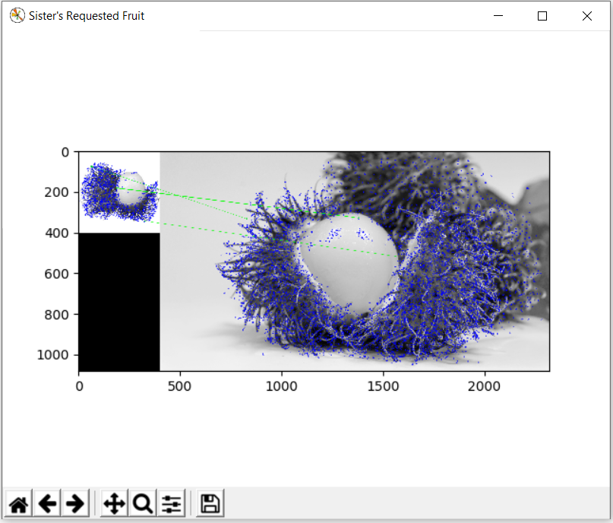

**Figure 1. The best result of feature matching**

**References:**

* <https://1.bp.blogspot.com/-cY6HdJu3Xro/Udl-xLl8MmI/AAAAAAAABLk/DVE6OOkpHiU/s400/Rambutan-3.jpg>
* <https://www.wallpaperflare.com/red-grapes-macro-fruit-wet-food-close-up-wellbeing-plant-wallpaper-bjg/download/1920x1080>
* <https://www.wallpaperflare.com/close-up-of-rambutan-fruit-background-fresh-white-red-food-wallpaper-zqkcu/download/1920x1080>
* <https://images.wallpaperscraft.com/image/orange_fruit_citrus_159655_1920x1080.jpg>
* <https://www.wallpaperflare.com/coconut-blast-split-spray-falls-wet-walnut-white-background-wallpaper-esfvh/download/1920x1080>
* <https://www.wallpaperflare.com/static/855/507/709/pineapple-fruit-plate-sliced-wallpaper.jpg>
* <https://www.wallpaperflare.com/sliced-avocado-fruit-beside-two-whole-ones-wallpaper-61827/1920x1080>
* <https://www.wallpaperflare.com/apple-fruit-slice-food-and-drink-healthy-eating-studio-shot-wallpaper-paka/download/1920x1080>
* <https://www.wallpaperflare.com/slice-of-papaya-with-black-background-wallpaper-12511/1920x1080>
* <https://www.wallpaperflare.com/slice-red-strawberry-60mm-f-2-8d-micro-nikkor-food-fruit-wallpaper-hubyd/download/1920x1080>
* https://www.wallpaperflare.com/fruits-melon-honey-dew-melon-wallpaper-shozi/download/1920x1080